

UNIVERSITI MALAYSIA TERENGGANU

FACULTY OF OCEAN ENGINEERING TECHNOLOGY & INFORMATICS

[CSM3114]

FRAMEWORK-BASED MOBILE APPLICATION DEVELOPMENT

TITLE: STUDENT GRAB APPLICATION

PREPARED BY:

NUR ELYA FARHANA BINTI ZAINORDIN (S63723)

PREPARED FOR:

DR. MOHAMAD NOR BIN HASSAN HASSAN

[BACHELOR OF COMPUTER SCIENCE (MOBILE COMPUTING) WITH HONOURS]

SEMESTER I 2023/2024

Contents

1.0 Executive summary of the prototype 3

2.0 The prototype design 4

3.0 The UI for the application with explanation 5

4.0 Potential commercial value and the pricing of the prototype 7

5.0 Lesson learned 8

6.0 Conclusion 8

7.0 Reference 9

## 1.0 Executive summary of the prototype

A clever approach to emphasize and improve university students' safety on their rides is the Student Grab Application. Considering occurrences of assault, kidnapping, and other safety concerns raising worries about student security, this app seeks to offer a dependable and safe transportation network. Inviting participation from all members of the university community, the platform allows students with legitimate driver's licenses to drive or ride as registered passengers, creating a welcoming and cooperative atmosphere. Student Grab's easy-to-use registration form guarantees a smooth onboarding process, allowing students to join the community fast.

The Student Grab Application stands out for its dedication to providing a personalized trip. The application enables users to customize their trips by choosing preferred routes and designating pick-up and drop-off locations, considering the varied demands of students. As a way to keep users informed about route modifications and emergency circumstances, the platform also incorporates real-time safety alerts and notifications. Because of the community-driven approach of the app, users are encouraged to actively participate and provide feedback, which allows the platform to be continuously improved and adjusted to meet the changing demands of college students.

In a nut, the Student Grab Application offers a safe, inclusive, and user-centered solution, which is a revolutionary leap forward in student mobility. The application resolves important safety issues within the university community by giving students the confidence to navigate their academic careers. Come along as we transform student transportation and build a more secure, welcoming campus community.

## 2.0 The prototype design

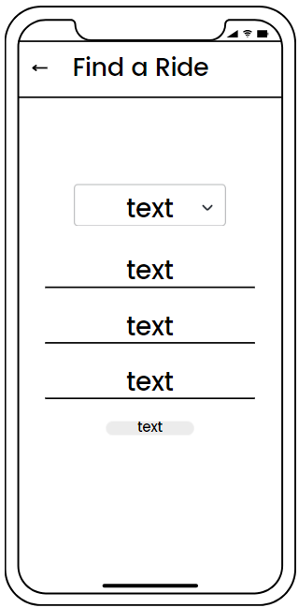

Homepage Find a Ride page

Offer a Ride page Available Ride Locations page

## 3.0 The UI for the application with explanation

This is my homepage of student grab application, where the user can navigate to go to the menu, to find a ride and offer a ride. This application works for both parties, neither the passenger who wants to find a ride nor the driver who wants to offer a ride. Firstly, the user may click on the menu icon to look at the list of ride location availability. In the Available Ride Locations page, there is an add icon, which enables the user to add more locations to be listed on that page. By clicking on the add icon, a show dialog will be displayed with two fields of name and details to be filled. User can press add to add on the list page and cancel to cancel the add new location action.

Next, the user may click on the Find a Ride button to find a ride and access Find a Ride page. In this page, user is obligated to fill in all fields by selecting the destination by choosing the available listed locations or addition of locations, fill in the name, phone number and which place the user wants the driver to pick up. Then, after clicking on the search for rides button, the user’s details will be displayed and navigate back to the homepage as shown on the UI above. If the user has found the driver, just tap on the box of details displayed and it will automatically remove it. Lastly, as for the user who wants to offer a ride, user may click on the button Offer a Ride to go to the page. The user is required to fill in the name, choose gender from the dropdown list, car plate number and phone number. By clicking on the Offer Ride button, the details filled by user will be displayed on the show dialog on the homepage to notify any user.

## 4.0 Potential commercial value and the pricing of the prototype

The Student Grab Application has a substantial market value, especially when it comes to college and university students. The app fills a vital demand for dependable and safe transportation, which makes it a popular choice among students who value convenience and well-being. The initial version is positioned as a wise investment for universities and colleges looking to improve the general safety and experience of their student, given the huge demand for such services.

Given its sophisticated features, security precautions, and potential benefits for improving student life, the prototype obtains a relatively expensive price. Students may still use and afford the app despite its competitive pricing. Aiming for a combination of providing a premium service with affordability, the pricing plan takes into account the financial constraints that students frequently encounter as a result of high living expenses. By ensuring increased safety and a chance for students to earn extra money by actively using the platform, our strategy seeks to make the Student Grab Application an essential tool for students.

In summary, the prototype's cost is commensurate with its substantial market potential, rendering it an attractive option for higher education institutions and learners alike. The Student Grab Application strikes an advantageous deal for both universities and students looking for a safe and revolutionary mobility experience because of its balance between premium features and affordability.

## 5.0 Lesson learned

There are several lessons learned by creating and developing the grab student application. The ListTile is implemented to ensure that title does not wrap, and to ensure that subtitle doesn't wrap and to be used for ListView. ListView used scrolling widget. It displays its children one after another in the scroll direction. In the cross axis, the children are required to fill the ListView. Drawer. It populates navigation and provides a consistent visual structure. Add adds value to the end of this list, extending the length by one. GestureDetector. The function is to remove the text when it is tapped or clicked. DropdownButtonFormField is implemented to drop down the list that has listed. TextEditingController is used for handling changes in a textfield or also known as a controller for an editable text field. TextFormField a FormField that contains a TextField, this is a convenience widget that wraps a TextField widget in a FormField. MaterialPageRoute is used to navigate to a new screen and back. Navigator.pop is used to return to the previous page while Navigator.push is used to navigate to any page we assigned to go, adds a Route to the stack of routes managed by the Navigator. Async, Asynchronous operations let your program complete work while waiting for another operation to finish like reading data from a file.

## 6.0 Conclusion

In a nutshell, several crucial features were included to improve the user experience when creating the Student Grab App, a comprehensive and user-focused transportation option for college students. By limiting the number of students who may register as drivers or passengers to those who possess valid licenses, the app addresses safety issues while facilitating safe and convenient transportation for students. Developing user-friendly interfaces that seamlessly gather and show user data, such the Find a Ride and Offer a Ride pages, was part of the development process. The application makes use of Flutter's features to provide a dynamic and user-friendly user interface. The Student Grab App is a useful tool for enhancing student safety and offers an effective mode of transportation for the university community thanks to its careful design and iterative development.

## 7.0 Reference

1. <https://api.flutter.dev/flutter/widgets/ListView-class.html>
2. <https://docs.flutter.dev/cookbook/design/drawer>
3. <https://dart.dev/codelabs/async-await>